Cover Letter 10 December 2022

Dear Editor,

On behalf of myself and co-author, I would like to kindly ask you to consider the manuscript entitled “**Foraging, fear and behavioural variation, a lesson from hummingbirds”** for publication in IBIS. The study benefited of Small Research Grant of British Ornithological Union (to Katarzyna Wojczulanis-Jakubas; acknowledged). The manuscript explores foraging efficiency of the long-billed hermit hummingbird (LBH, *Phaethornis longirostris*) in the context of high and low perceived risk of predation, and in respect to birds exploratory behaviour, risk-avoidance and arousal. We show that foraging efficiency decreases in response to threatening conditions, and birds behavioural performance affects their foraging efficiency. What is even more interesting, we show that birds behaviour affects foraging efficiency in context-dependent manner. Our results, based on a bird species of extremely high energy demands, provide excellent support for the risk-allocation hypothesis, RAH (and paradox of RAH), and also highlight the importance of behavioural variability in shaping evolution of foraging strategy. I believe that the manuscript provides results that are interesting for a broad range of readers of IBIS. I declare no conflict of interests and that manuscript is not considered in any other journal, neither contain materials with copyrights.

Thank you in advance for your time with the manuscript.

Looking forward to hearing from you soon.

Sincerely yours,

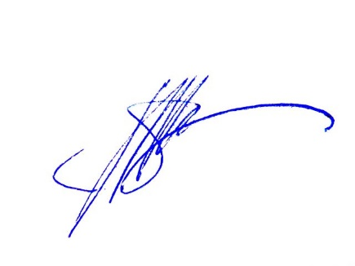

Katarzyna Wojczulanis-Jakubas

University of Gdańsk, Poland